VIETNAM WAR DBQ ESSAY EXAM STUDENT INSTRUCTIONS
Framework/Historical Context:
The Vietnam War began in the early 1960s with the U.S. sending military advisors to South Vietnam. U.S. troops remained until 1975 when North Vietnamese Communist forces took control of the entire county. This war is arguably the most controversial war having caused a massive anti-war movement and a great amount of political turmoil as it dragged on.
In an essay of four paragraphs (introduction, two to four body paragraphs, and a conclusion), answer the following question:
How was a small country like Vietnam able to defeat a superpower like the United States during the Vietnam War? (Consider these areas: military, economic, political, social)
Directions:
- Carefully read through and analyze each document. Answer the document questions.
- Form a thesis/claim. Remember, your thesis/claim should be the last sentence of your introduction and clearly state your focus and purpose for your writing. Underline your thesis/claim statement
- Write an introduction where you give some background on the Vietnam War.
- Write your body paragraphs.
  - BE SURE TO USE SPECIFIC EVIDENCE FROM THE DOCUMENTS AS WELL AS SPECIFIC HISTORICAL DETAILS TO SUPPORT YOUR CLAIMS. Feel free to include additional information from what you learned in class.
- Write a conclusion paragraph that restates your thesis/claim and connects the topic to another event, modern society, or the bigger picture.
- After you are done writing your essay, use the Student Checklist below to make sure that you have all parts of the essay done.
Parts of a Summary | Expectations | Done | Not Done
Introduction paragraph | - First few sentences of my introduction is interesting to the reader and addresses my topic
 | - I have a clear thesis/claim statement that answers the question & is the last sentence in the introduction & is underlined
Body | - I state two to four reasons and explain them well.
 | - I use specific information or a quote from between two and six of the documents
 | - My body paragraphs have a topic sentence and contain information about just one topic
 | - I use vocabulary that I learned in class that is specific to my social studies class
Conclusion | - My conclusion sums up my main points and leaves the reader thinking about how this topic fits into something else.
Overall | - I have showed that I can read documents past just the literal meaning
 | - I have showed that I really understand the topic beyond just memorization of facts

Document 1: Political Cartoon
What problem regarding the Vietnam War effort is this cartoon addressing?

Document 2: Song Lyrics: “I-Feel-Like-I’m-Fixin’-To-Die,” by Country Joe and the Fish, 1965.
Is the intent of this song to promote or protest the Vietnam War?

Who does Joe McDonald blame for having financial interests in the war effort?

Document 3: Martin Luther King, 1967
What is Martin Luther King Jr.’s main concern regarding the Vietnam War?

Document 4: An interview with Hubert H Humphrey with Bill Moyer, The Art of the Possible
What problem with the Vietnam War was Humphrey talking about in this part of the interview?

Document 5: Picture: U.S. soldier carries a M67 recoilless rifle past a burning Viet Cong base camp in My Tho, South Vietnam, 1968
Why would activities like this make it difficult for the United States to “win the hearts and minds” of the Vietnamese?

Document 6: George McGovern, 1972
How did this perspective on how to fight the Vietnam War impact the outcome of the war?

Document 7: Picture of the protests at the Democratic National Convention in Chicago in 1968
How would protests in the United States affect the outcome in Vietnam?

Document 8: Vietnamese Declaration of Independence
What are the basic beliefs stated in this document?

How would fighting against a nation that held these beliefs be difficult for the US?

Document 9: A diagram of the tunnel complex for the Viet Cong
Why would it be difficult to fight against an enemy that used guerrilla tactics like these tunnels?

Document 10: Photograph: 1967, Wichita, Kansas protests
What does this photo say about how people in the US thought about the Vietnam War?

Documents for Analysis
Directions: The following eight documents relate to the social, political, military, and economic reasons Vietnam was able to defeat the United States during the Vietnam War. Examine each document carefully and then take notes on the Brainstorming and Note taking Worksheet.
Document 1: Political Cartoon

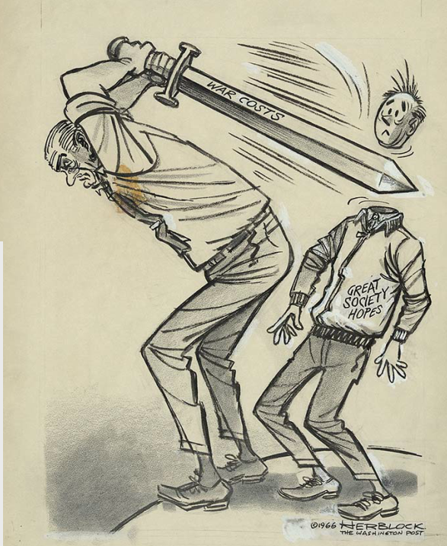
http://www.npg.si.edu/exhibit/herblock/Johnson.html

Document 2: Song Lyrics: “I-Feel-Like-I’m-Fixin’-To-Die,” by Country Joe and the Fish, 1965.
Well, come on Wall Street, don’t move slow,
Why man, this is war au-go-go.
There’s plenty good money to be made
By supplying the Army with the tools of the trade,
Just hope and pray that if they drop the bomb,
They drop it on the Viet Cong.
And it’s one, two, three,
What are we fighting for?
Don’t ask me, I don’t give a damn,
Next stop is Vietnam.
And it’s five, six, seven,
Open up the pearly gates,
Well there ain’t no time to wonder why
Whoopee! we’re all gonna die.
Well, come on mothers throughout the land,
Pack your boys off to Vietnam.
Come on fathers, don’t hesitate,
Send ’em off before it’s too late.
Be the first one on your block
To have your boy come home in a box.
I Feel Like I’m Fixin’ to Die Rag, words and music by Joe
McDonald. Copyright ©1965 renewed 1993 by Alkatraz Corner
Music Co. All rights reserved. Used by permission.
Document 3: Martin Luther King, 1967
“. . . it became clear to me that the war was doing far more than devastating the hopes of
the poor at home. It was sending their sons and their brothers and their husbands to fight
and die in extraordinarily high proportions relative to the rest of the population. We were
taking the black young men who had been crippled by our society and sending them
eight thousand miles away to guarantee liberties in Southeast Asia which they had not
found in southwest Georgia and East Harlem.”

Document 4: An interview with Hubert H Humphrey with Bill Moyer, The Art of the Possible
HUMPHREY: We do not want a police state, but we need a state of law and order. And neither mob violence or police brutality have any place in America. Are we to be one nation, or are we to be a nation divided - divided between black and white, between rich and poor, between north and south, between young and old. Rioting, burning, sniping, mugging, traffic in narcotics and disregard for law, are the advance guard of anarchy, and they must and they will be stopped!

Document 5: Picture: U.S. soldier carries a M67 recoilless rifle past a burning Viet Cong base camp in My Tho, South Vietnam, 1968
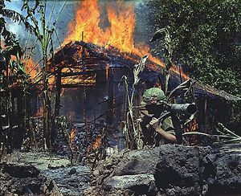
http://www.cs.mcgill.ca/~rwest/wikispeedia/wpcd/wp/v/Vietnam_War.htm
Document 6: George McGovern, 1972
“What I propose is that we spend all that is necessary for prudent national defense, and no
more. I propose that we conserve our limited resources:
-By no longer underwriting the appalling waste of money and manpower that has become
such a bad habit in our military establishment;
-By rejecting the purchase of weapons which are designed to fight the last war better, with
almost no relevance to today’s threat;
-By refusing to maintain extra military forces that can have no other purpose than to repeat
our experience in Vietnam, a venture which nearly all of us now recognize as a monstrous
national blunder;
-By repudiating the false world of old discredited myths, made up of blocs, puppets, and
dominoes, facing instead the real world of today and the future with multiple ideologies
and interests.”
*Repudiate= Reject

Document 7: Picture of the protests at the Democratic National Convention in Chicago in 1968
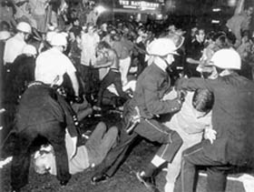
http://faculty.smu.edu/dsimon/Change-Viet3b.html
Document 8: Vietnamese Declaration of Independence
All men are created equal. They are endowed by their Creator with certain inalienable rights; among these are Life, Liberty, and the pursuit of Happiness."
This immortal statement was made in the Declaration of Independence of the United States of America in 1776. In a broader sense, this means: All the peoples on the earth are equal from birth, all the peoples have a right to live, to be happy and free.
The Declaration of the French Revolution made in 1791 on the Rights of Man and the Citizen also states: "All men are born free and with equal rights, and must always remain free and have equal rights."
Those are undeniable truths.
Nevertheless, for more than eighty years, the French imperialists, abusing the standard of Liberty, Equality, and Fraternity, have violated our Fatherland and oppressed our fellow citizens. They have acted contrary to the ideals of humanity and justice.
For these reasons, we, members of the Provisional Government of the Democratic Republic of Vietnam, solemnly declare to the world that Vietnam has the right to be a free and independent country-and in fact is so already. The entire Vietnamese people are determined to mobilize all their physical and mental strength, to sacrifice their lives and property in order to safeguard their independence and liberty. ^{[1]}
Document 9: A diagram of the tunnel complex for the Viet Cong
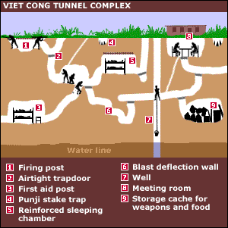
Document 10: Photograph: 1967, Wichita, Kansas protests
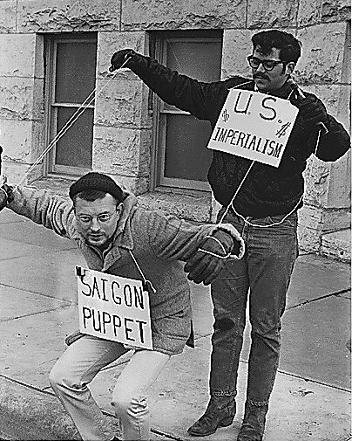
From the 1967. U.S. archives

